How did we do?

Were you happy with our service?

If so, then please help us get the word out

And LEAVE a REVIEW at –

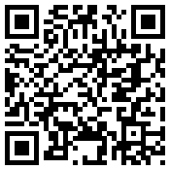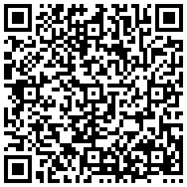

Yelp

Google

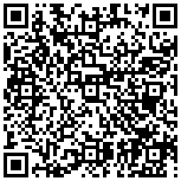

© Copyright 2012, Kat & Mouse | www.katandmouse.com

YP.com

Just scan one or all of these QR codes with your phone’s QR reader and you’ll be taken to the review page.

Thank you for taking the time to help us spread the word!

And thank you for letting   
us serve you. It’s been our pleasure!